Installation Guide

* Requirement: IOS device(with Bluetooth), MAC, data line
* Steps:

1. Open project using Xcode on the Mac:

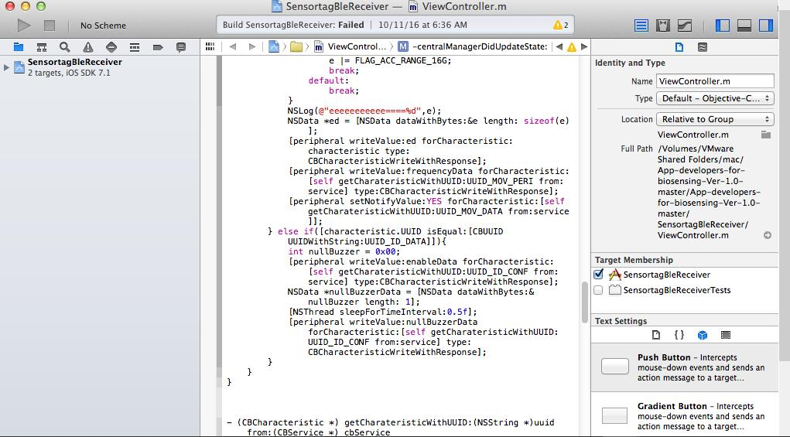

1. Use data line to connect the IOS device with MAC.
2. Configure this page successfully:

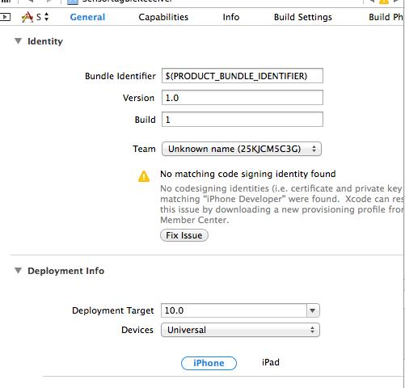

1. On the left-top of Xcode, Find “Scheme” menu and select your IOS device.
2. Press “Deploy” menu.
3. Finally, we can deploy our project to the IOS device:

